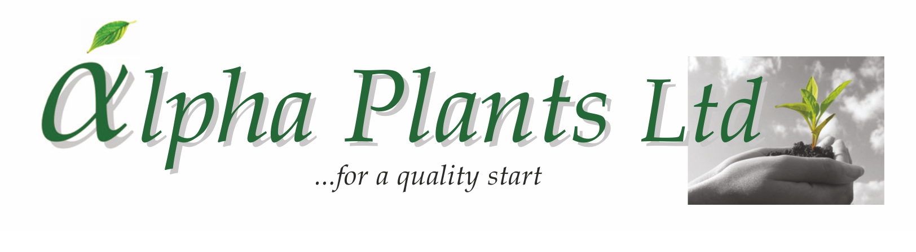


Availability for Delivery

2025

Company Name………………………………………………………………………………………………………

Address…………………………………………………………………………………………………………………...

………………………………………………………………………………………………………………………………………………………………………….

………………………………………………………………………………………………………………………………..

VAT Number…………………………………………... Purchase Order Number………………………………

Contact Name …………………………………………. Phone Number …………………………………….

Email Address ……………………………………………………………………………………………………………

Delivery Address (if Different) …………………………………………………………………………………………...

………………………………………………………………………………………………………………………………..

...................................................................................................................................................................................................

How to Order:

- Complete Company name and address details together with required delivery week.

- Complete the number of trays required by variety. Sold as 100 trays. Prices are quoted ex VAT, ex nursery and do not include transport. Transport will be quoted separately where required.

- Send your order back to us either by Email: enquiries@alphaplants.co.uk or by post to
Alpha Plants Ltd, Millview Nurseries, Fengate Road, West Pinchbeck, Spalding, Lincolnshire PE11 3NE.

4) Any questions, please call us on (01775) 640150 or Email: enquiries@alphaplants.co.uk

VAT Registration Number: 367 6849 36 Plant Passport Number: GB 32470


Plant | Variety | Cell  Tray Size | Price  per  Plug | Royalty per  Plug | DELIVERY WEEK(s)  …………………………………..
 |  |  |  |  | Number of Trays required:
Victorian Viola | Abigail | 100 | 39.5p | 5p
Victorian Viola | Blue Ice | 100 | 39.5p | 5p
Victorian Viola | Blue Sails | 100 | 39.5p | 5p
Victorian Viola | Bridie | 100 | 39.5p | 5p
Victorian Viola | Budgie | 100 | 39.5p | 5p
Victorian Viola | Citronella | 100 | 39.5p | 5p
Victorian Viola | Cockatoo | 100 | 39.5p | 5p
Victorian Viola | Cuty | 100 | 39.5p | 5p
Victorian Viola | Elaine Quin (Heritage) | 100 | 39.5p | 5p
Victorian Viola | Hannah May | 100 | 39.5p | 5p
Victorian Viola | Isabel (Heritage) | 100 | 39.5p | 5p
Victorian Viola | Ivory Queen (Heritage) | 100 | 39.5p | 5p
Victorian Viola | Mabel | 100 | 39.5p | 5p
Victorian Viola | Maggie Mott (Heritage) | 100 | 39.5p | 5p
Victorian Viola | Martini | 100 | 39.5p | 5p
Victorian Viola | Midnight | 100 | 39.5p | 5p
Victorian Viola | Nora (Heritage) | 100 | 39.5p | 5p
Victorian Viola | Prunella | 100 | 39.5p | 5p
Victorian Viola | Queenie | 100 | 39.5p | 5p
Victorian Viola | Rosy Rayne | 100 | 39.5p | 5p
Victorian Viola | Smuggler’s Moon (Heritage) | 100 | 39.5p | 5p
Victorian Viola | Sunny Jim | 100 | 39.5p | 5p
Victorian Viola | White Swan (Heritage) | 100 | 39.5p | 5p
Victorian Viola | Winifred Jones (Heritage) | 100 | 39.5p | 5p

